Module Code: COS1511
Assessment: Assignment 1
Student Number: 69234175
Name: Jaymeen Patel

QUESTION 1

#include <iostream>

using namespace std;

int main()
{ //Variables
int mFactor, flour=2, bakingpowder=3, lemonzest=1, egg=1;
float sugar=0.5, salt=0.5, milk=0.75, oil=0.25 ;

cout<<("Please enter the factor to multiply the ingredients with : ");
cin>>mFactor;
flour=flour*mFactor, bakingpowder=bakingpowder*mFactor, lemonzest=lemonzest*mFactor,
egg=egg*mFactor, sugar=sugar*mFactor, salt=salt*mFactor, milk=milk*mFactor, oil=oil*mFactor;

cout<< "Recipe for Lemon Muffins " << endl;
cout<<"Ingredients: "<<endl;
cout<< flour << " cups of all-purpose flour "<< endl;
cout<< bakingpowder << " teaspoons of baking powder "<< endl;
cout<< lemonzest << " tablespoons of grated lemon zest "<< endl;
cout<< egg << " eggs "<< endl;
cout<< sugar << " cups of sugar "<< endl;
cout<< salt << " teaspoons of salt "<< endl;
cout<< milk << " cups of milk"<< endl;
cout<< oil << " cups of vegetable oil"<< endl;

cout<<endl;

cout<<"Method: "<<endl;
cout<<"1. Heat oven to 400 degrees F (205 degrees C). Grease bottoms only of 12 muffin cups or line with baking cups."<<endl;
cout<<"2. In a medium bowl, combine flour, sugar, baking powder, lemon zest and salt; mix well."<<endl;
cout<<"3. In a small bowl, combine milk, oil and egg and blend well"<<endl;
cout<<"4. Add dry ingredients all at once; stir just until dry ingredients are moistened (batter will be lumpy.)"<<endl;
cout<<"5. Fill cups 2/3 full, bake for 20 to 25 minutes or until toothpick inserted in center comes out clean."<<endl;
cout<<"6. Cool 1 minute before removing from pan and serve warm."<<endl;

return 0;
}

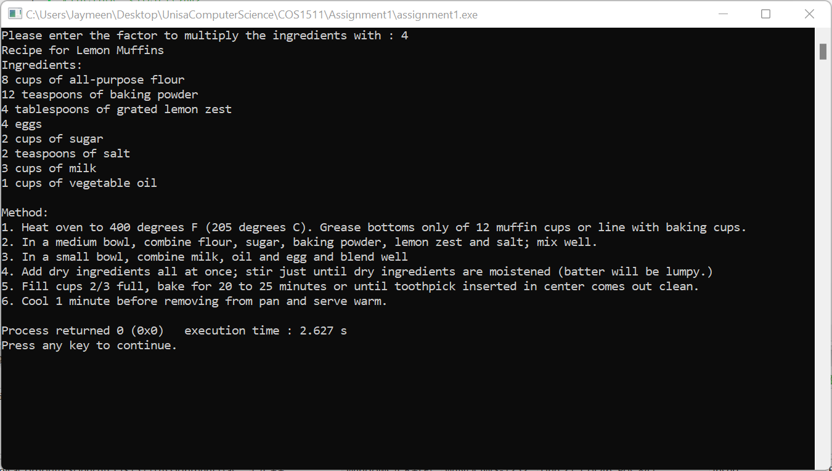

Question 2

#include <iostream>
using namespace std;

int main()
{
//Variables
int nrPupils = 56, nrGroups, nrLeft, groupSize;

cout<< "Please enter the size of each group?" << endl;
cin>>groupSize;
//Calculate the group size
nrGroups=nrPupils/groupSize;
//Calculate the pupils left over
nrLeft=nrPupils%groupSize;
//Display output
cout << "There are "<<nrGroups<< " groups consisting of " << groupSize << endl;
cout << "pupils, There are " << nrLeft <<" remaining pupils" ;

return 0;
}

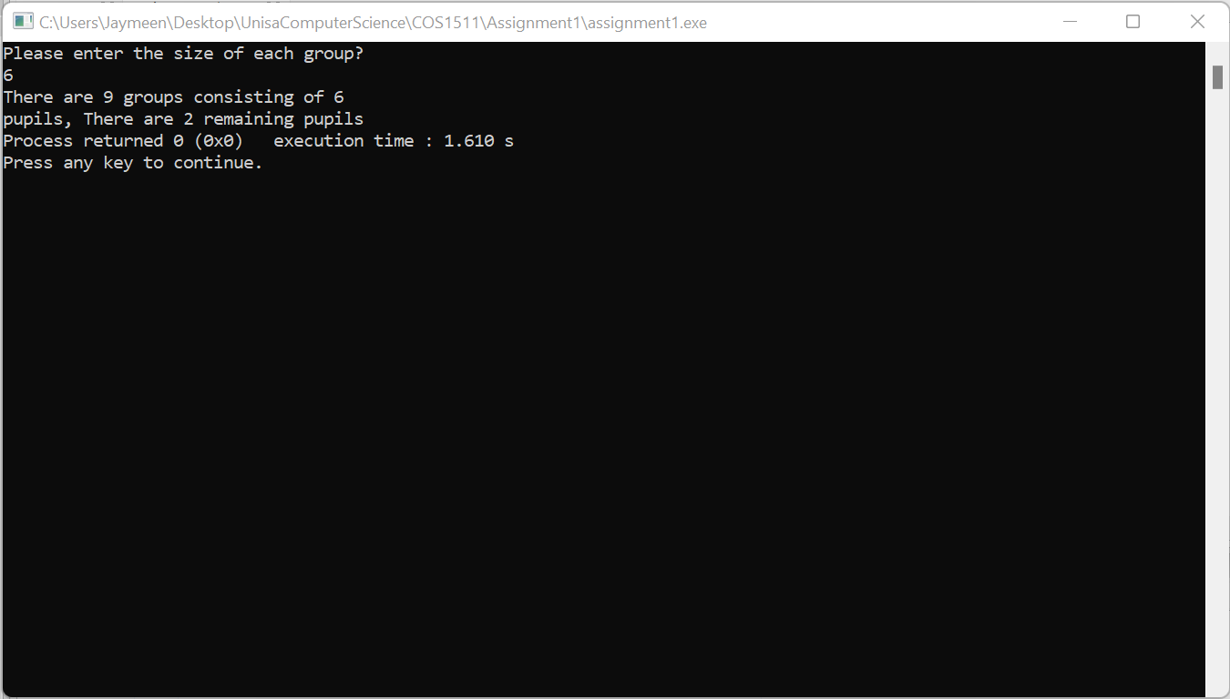

Question 3

#include <iostream>
using namespace std;

int main()
{ //Variables
float var1, var2;
char operation;
//Getting input from user
cout<<"Please enter the first float value: ";
cin>>var1;
cout<<"Please enter the second value: ";
cin>>var2;

cout<<"Please enter the operation required : ";
cin>>operation;
//Getting output to 2 decimal points only
cout.setf(ios::fixed);
cout.precision(2);
//If statements
if (operation=='+')
cout << "The sum of " << var1 << " and " << var2 << " is " << var1+var2;
else if (operation=='-')
cout << "The difference of " << var1 << " and " << var2 << " is " << var1-var2;
else if (operation=='*')
cout << "The product of " << var1 << " and " << var2 << " is " << var1*var2;
else if (operation=='/')
if(var2==0)
cout<< "Error, cannot divide by 0";
else
cout << "The quotient of " << var1 << " and " << var2 << " is " << var1/var2;
// else if (operation=='%')//Modulus is not supported on float variables so I had to convert to integer
// cout << "The remainder of " << var1 << " and " << var2 << " is " << int(var1)%int(var2);
else cout << "Please enter valid operation such as '+' or '-' ";

return 0;
}

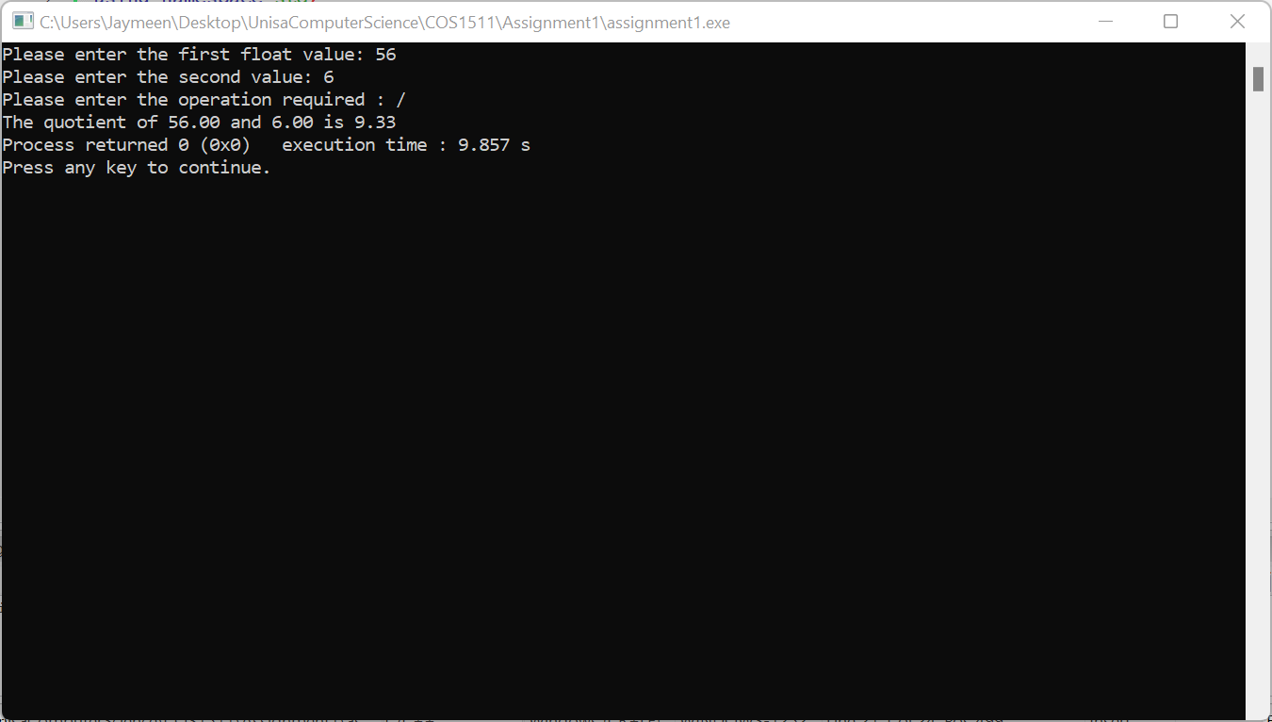

Question 4

#include <iostream>
using namespace std;

int main()
{ //Variables
int progsramsDone, result;

//Initialising variables
cout << "Please enter number of programs done and mark obtained? "<< endl;
cin >> progsramsDone;
cin >> result;

//Start of while loop
while (progsramsDone<5 || result<50)
{
cout << "Please enter number of programs done and mark obtained? ";
cin >> progsramsDone;
cin >> result;
}
//Statement when loop is false
cout << "Good! You can now proceed to the next exercise"<< endl;

return 0;
}

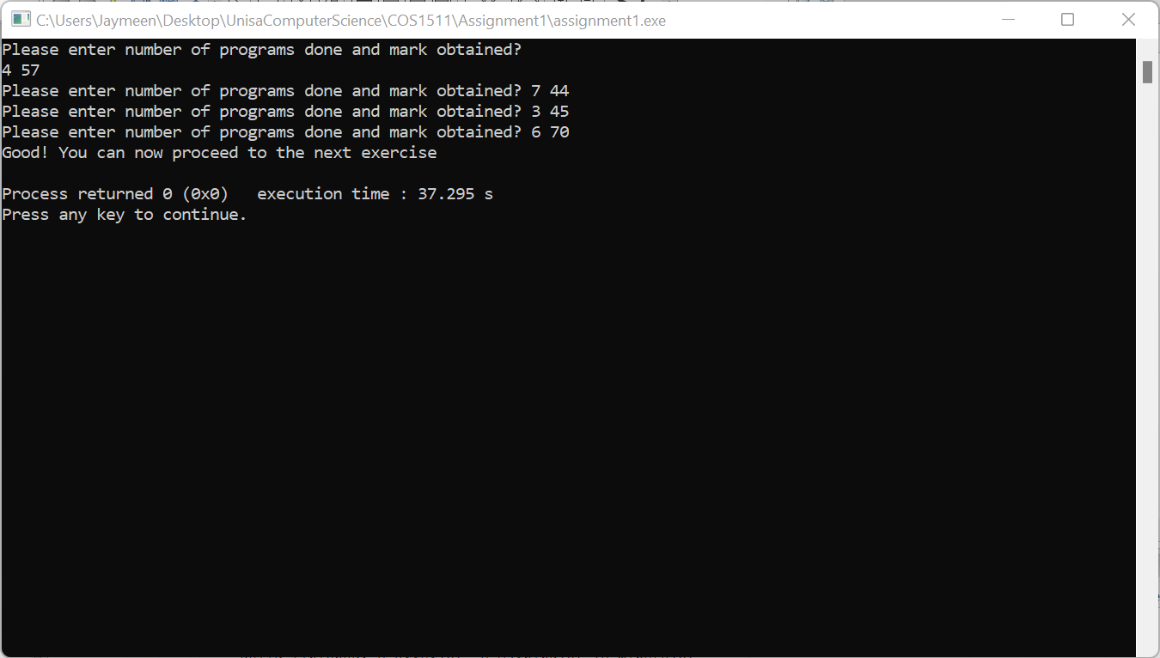

Question 5

#include <iostream>
using namespace std;

int main()
{ //Variables
int i, n;
//Variable initialisation
i=1;
n=10;
//While loop
while (i<=n)
{
cout << i * i;
i++;
}

return 0;
}

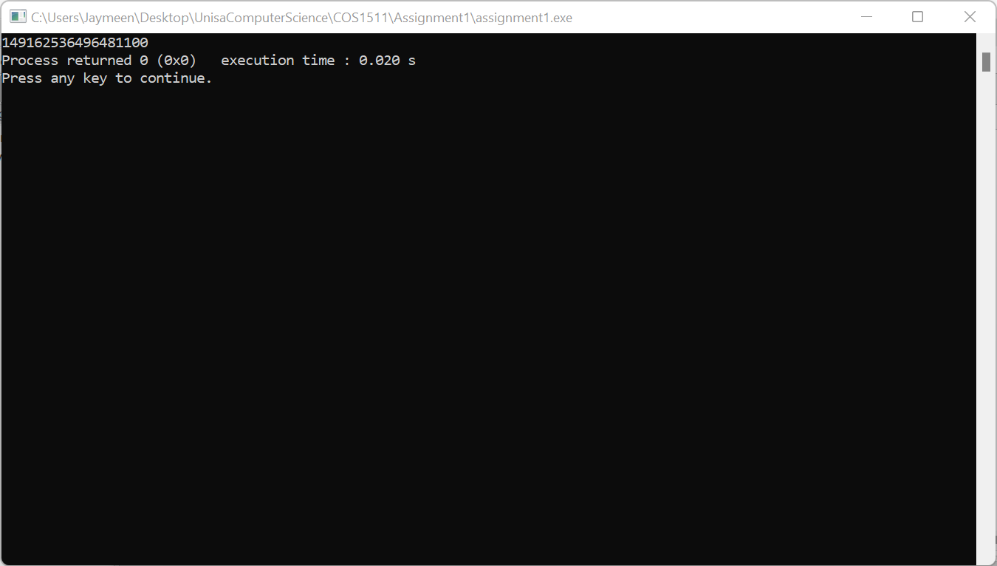
Question 6

First Version(Switch)

#include <iostream>
using namespace std;

int main()
{ //Variables
float amount, discount, finalAmount;
char customerType;
//Getting input from user
cout << "Please enter total amount due: R";
cin >> amount;
cout << "Please enter what type of customer are you? : " << endl;
cout << "Type S for Student" << endl;
cout << "Type D for Bookdealer" << endl;
cout << "Type P for Pensioner" << endl;
cout << "Type O for Other" << endl << endl;

cin>>customerType;

//Start of switch statement
switch(customerType)
{case 'S':
case 's':
discount = amount * 0.1;
finalAmount = amount - discount;
break;
case 'D':
case 'd':
discount = amount * 0.12;
finalAmount = amount - discount;
break;
case 'P':
case 'p':
discount = amount * 0.15;
finalAmount = amount - discount;
break;
case 'O':
case 'o':
if (amount>200)
{ discount = amount * 0.1;
finalAmount = amount - discount;
}
else finalAmount = amount;
break;
}
//Set decimal points to 2 places
cout.setf(ios::fixed);
cout.precision(2);
//Display output
cout << endl;
cout << "The final amount due after discount is: R" << finalAmount;

return 0;
}

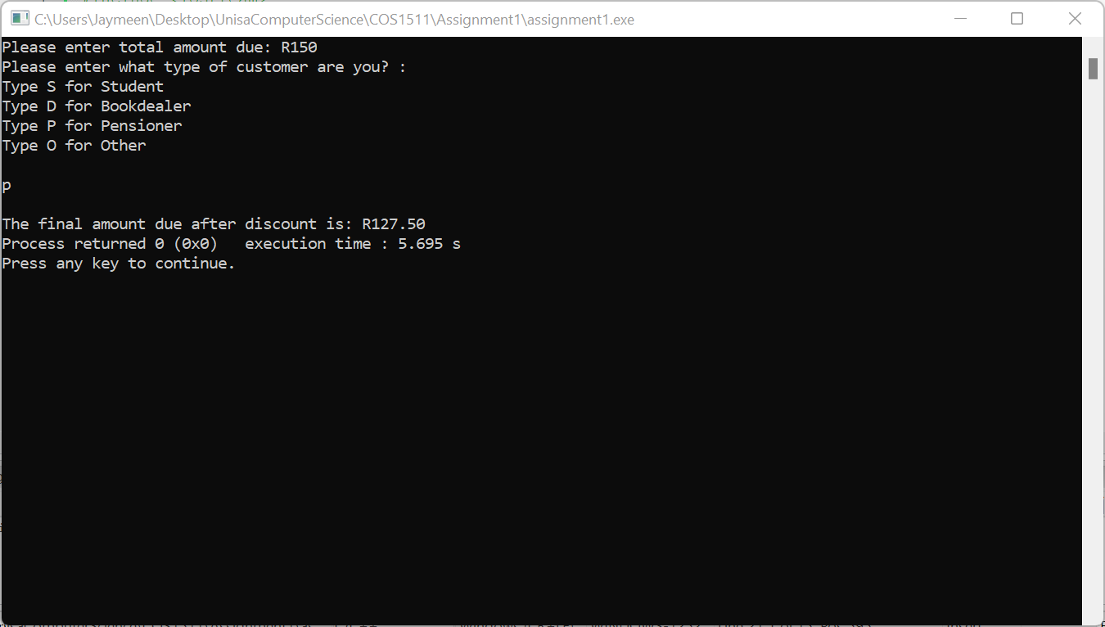

Version 2(Nested if statements)

#include <iostream>
using namespace std;

int main()
{ //Variables
float amount, discount, finalAmount;
char customerType;
//Getting input from user
cout << "Please enter total amount due: R";
cin >> amount;
cout << "Please enter what type of customer are you? : " << endl;
cout << "Type S for Student" << endl;
cout << "Type D for Bookdealer" << endl;
cout << "Type P for Pensioner" << endl;
cout << "Type O for Other" << endl << endl;

cin>>customerType;

//Start of Nested if statements
if (customerType == 'S' || customerType == 's' )
{
discount = amount * 0.1;
finalAmount = amount - discount;
}
else if (customerType == 'D' || customerType == 'd')
{
discount = amount * 0.12;
finalAmount = amount - discount;
}
else if (customerType == 'P' || customerType == 'p')
{
discount = amount * 0.15;
finalAmount = amount - discount;
}
else if (customerType == 'O' || customerType == 'o')
{
if(amount > 200)
{
discount = amount * 0.1;
finalAmount = amount - discount;
}
else finalAmount=amount;
}

//Set decimal points to 2 places
cout.setf(ios::fixed);
cout.precision(2);
//Display output
cout << endl;
cout << "The final amount due after discount is: R" << finalAmount;

return 0;
}

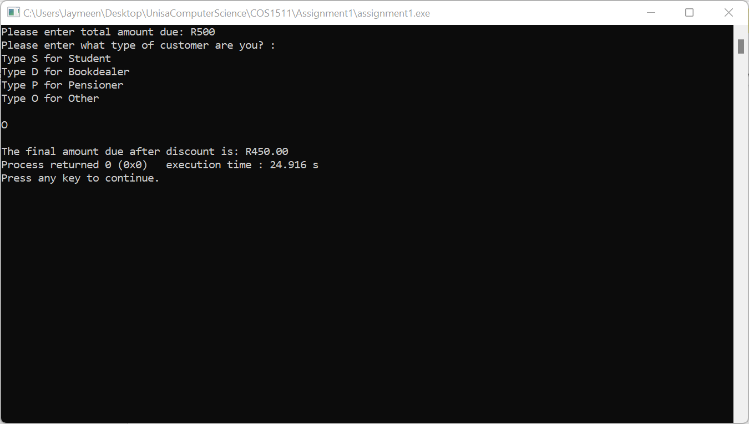

Question 7

The logical error is that the x variable is declared as 1, which is an odd number therefore the loop which should stop when x is equal to 12 will never end and the output of the code will be a never ending loop.

#include <iostream>
using namespace std;

int main()
{ //Variables
int x = 2;
while (x!= 12)
{
cout << x << endl;
x = x + 2;
}

return 0;
}

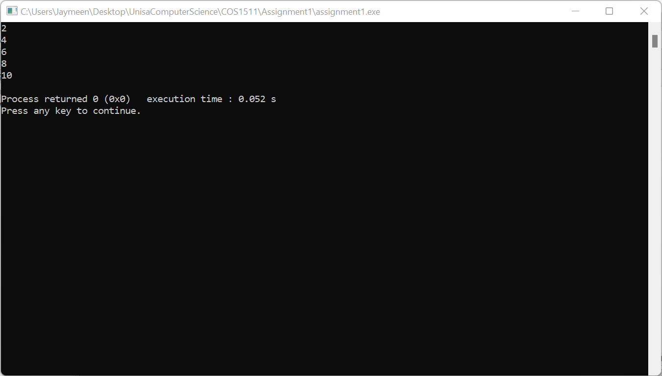

Question 8

While loop method

// Your code
totalCalories = 0;
count = 0;
while (count != numberOfItems)
{
cin >> caloriesForItem;
totalCalories = totalCalories + caloriesForItem ;
count++;
}
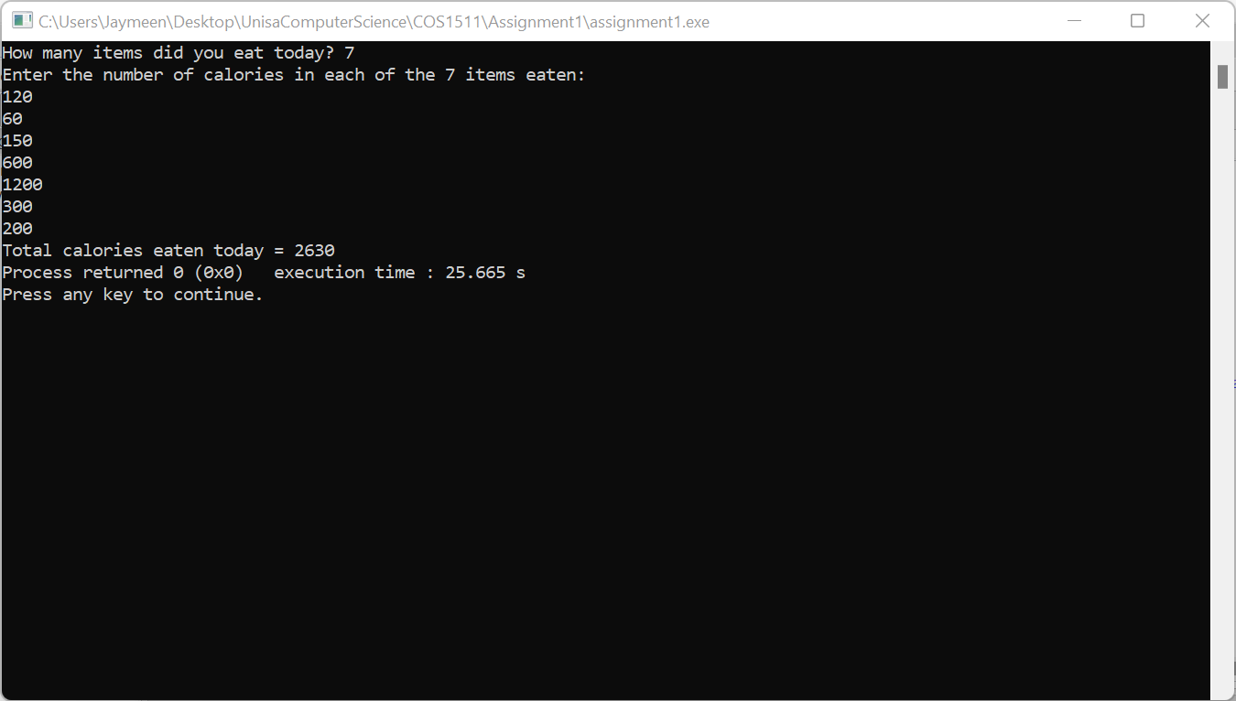

For loop method

// Your code
totalCalories = 0;
for (count = 0; count != numberOfItems; count++)
{
cin >> caloriesForItem;
totalCalories = totalCalories + caloriesForItem ;
}


Question 9

#include <iostream>
using namespace std;

int main()
{ //Variables
int votesForA = 0, votesForB = 0, votesForC = 0, spoiltVotes = 0;
int i;
char voteOption;

//Start of for loop
for(i = 1; i<5; i++ )
{
cout << "Please enter votes for voting station " << i << endl;
//Start of while loop to get input
while(voteOption != 'X' && voteOption != 'x')
{
cout << "Please enter which candidate you want to vote for using 'A', 'B' or 'C', 'X' terminates voting: " << endl;
cin >> voteOption;
cout << endl;
//Start of switch statement to assign votes gotten from input to variables
switch(voteOption)

{

case 'A':
case 'a': votesForA++;
break;

case 'B':
case 'b': votesForB++;
break;

case'C':
case'c': votesForC++;
break;

default: if (voteOption != 'X' && voteOption != 'x')
spoiltVotes++;
break;
}
}
//voteOption is assigned to 'Z' so when user chooses 'X' it doesnt skip the rest of the voting stations it reinitializes the voteOption variable
voteOption='Z';

}
//Displaying output
cout << "Total number of votes for candidate A = " << votesForA << endl;
cout << "Total number of votes for candidate B = " << votesForB << endl;
cout << "Total number of votes for candidate C = " << votesForC << endl;
cout << "Total spoilt votes = " << spoiltVotes << endl;

return 0;
}

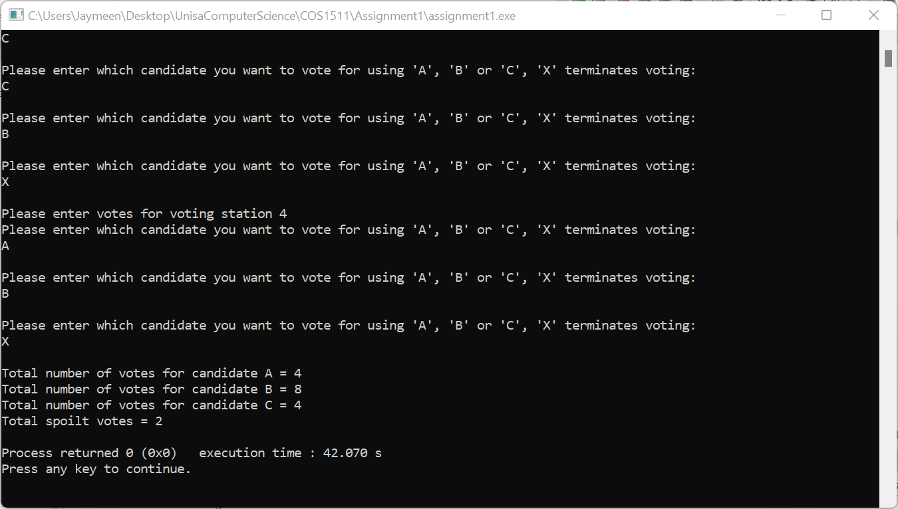

Question 10

 | year | code | book | Discount
Line 6 | ? | ? | ? | ?
Line 7 | ? | ? | true | 0.20
Line 8 | 2010 | t | true | 0.20
Line 20 | 2010 | t | false | 0.20
Line 21 | 2010 | g | false | 0.20

